**CHAPTER 6 EXERCISE 2A**

2. Consider Table 6-2. All duration estimates or estimated times are in days, and the network proceeds from Node 1 to Node 9. (Note that you can easily change this table to create multiple exercises.)

Table 6-2 Network diagram data for a small project

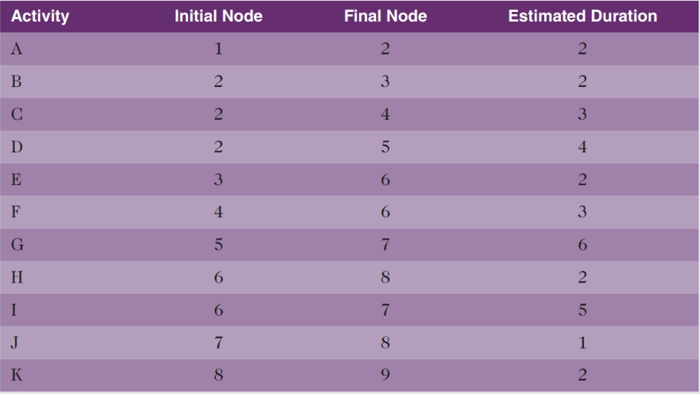

a) Draw an AOA network diagram representing the project. Put the node numbers in circles and draw arrows from node to node, labeling each arrow with the activity letter and estimated time.

K=2

J=1

H=2

I=5

G=6

F=3

E=2

D=4

C=3

B=2

A=2

2

5

4

3

7

6

8

9

1